Dear park center customers,
Park Center Water District  Tel (719)275-2055 Fax (719)275-0268  wadepctp@hotmail.com | 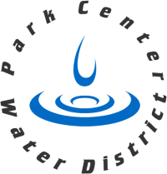

This letter is to notify you that Park Center has resolved the Trihalomethane (THM) Violation with the Colorado Department of Public Health and Environment (CDPHE). While the water was always safe to drink, we take any violation very serious and would like to give our customers some information on what caused the issue, what we did to resolve it and what we are doing to prevent this from happening.
Warmer weather and reduced moisture in the fall and winter of 2017 caused higher than normal organic material in our surface water. The organic material and chlorine used for disinfection of the water caused the formation of higher levels of THM’s. Our tests in November were higher than average for that time of year, causing our February tests to put us over the Maximum Contaminant Level (MCL), even though the tests in February were below the MCL. Our tests in May were also below the MCL, but the average remained above the MCL. Our tests in August put the average below the MCL.
To reduce the THM levels we adjusted how we blend our surface water, optimized the treatment plant, reduced the tank levels to minimize storage time, and flushed the lines more frequently. We also worked with a drinking water coach from the CDPHE to make sure we were conforming to state standards. We will continue to monitor water quality with the measures put into place to maintain low levels of THM’s.

Sincerely,
Board of Directors
Park Center Water District

